1. In the search bar search for “request one time payment” task.

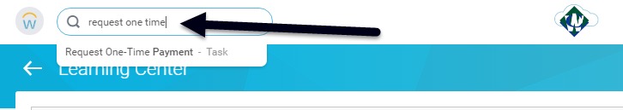

1. Select the effective date and the employee name.

NOTE: The Effective date should always be the Friday before the check date you want it paid on. The “effective date” needs to be within the pay period we are running. So the Friday prior to the check date you want it paid on will always work.

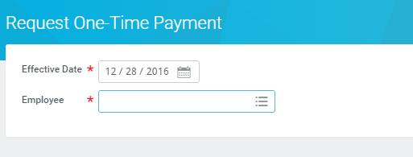

1. On the next screen choose the “add” button.

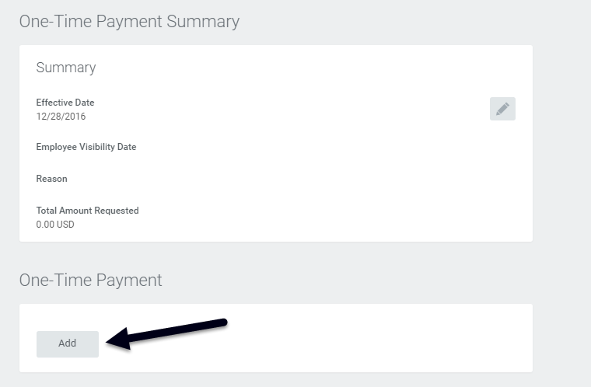

1. Choose the one-time payment plan type and amount
2. NOTE: Scheduled Payment Date should be the same as the effective date above.

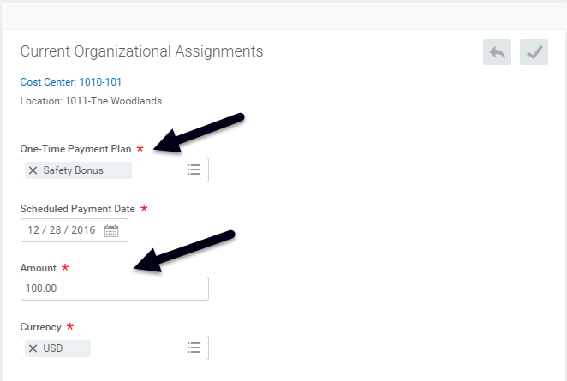

1. Add your comments to the additional information field as well as upload any supporting documentation required by your region. Click Submit.

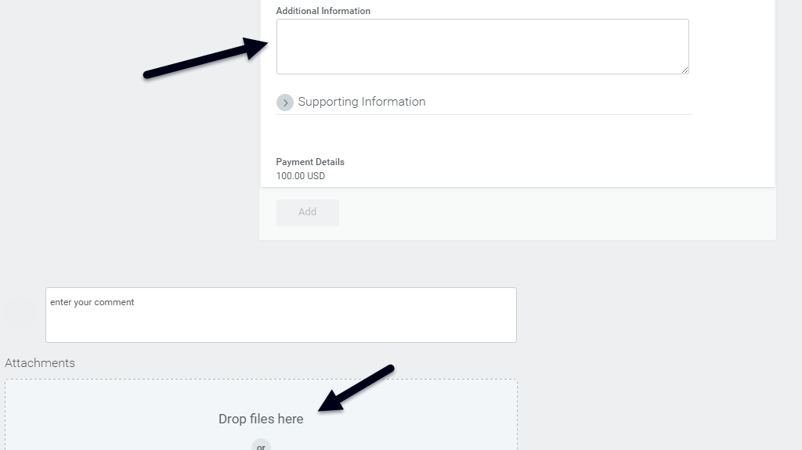

Once the one-time payment is submitted it will route for approval and process on the employees next scheduled pay date.